Name: Sim Justin

Matric No: A0257926N

Project 1: PID Control

# Initial Conditions

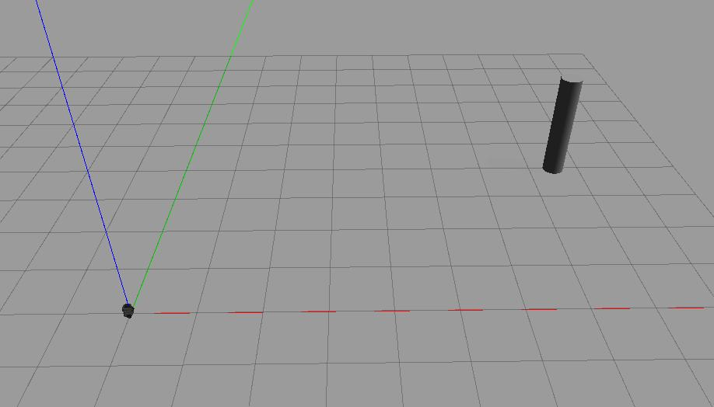

Figure I: Initial Location of Pillar and Turtlebot3

Starting Location of Pillar: (7.5, 4)

Stopping Distance: 1.1

Initial Distance: 8.5

Orientation of Pole: 0.489957326 rad

# Implementation of PID Control

Trapezoidal Riemann Sum vs Classical Riemann Sum for more accurate estimation of integral

<https://www.statisticshowto.com/calculus-problem-solving/riemann-sums/>

# Tuning of PID Control

# Performance of PID Control

# Conclusions

1. Initial conditions.
   1. Show the initial location of the pillar and the Turtlebot3 of your setting. Use the view that best show their locations.
   2. Calculate the initial distance and orientation of the pole with respect to the Turtlebot3.
2. Implementation of PID control. Discuss how the PID control is implemented in ROS with reference to your code.
   1. Describe how you (1) define the integral term, (2) define the derivative term and (3) define the PID control term
   2. Describe the purpose of the code to (1) regularize the angular error (error_angle) and (2) limit the angular control signal (trans_angle).
3. Tuning of PID.
   1. Discuss the tuning process, e.g., which gain is determined first, which gain is determined second, how it is determined and so on.
   2. Discuss how you would characterise the PID control (P, PI, PD or PID). Discuss the merits, demerits, and other points that you want to highlight about your design.
4. Performance of PID control.
   1. Attach the plots of errors vs time (both linear and angular errors) that represents your best design.
   2. Analyse the performance, e.g., overshoot, steady state error and settling time.
5. Conclusions and key learning points.